Cell Transport
Phospholipid Bilayer a.k.a the _____________ ______________________________
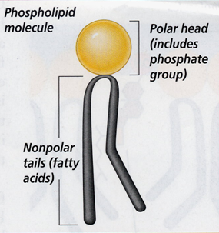
- Regulates what _____________ and __________ the cell.
- Selectively Permeable
- Provides _____________________ and_______________________.
- Composed of ______ Flexible Layers
- Forms a strong barrier between the cell and its surroundings
Phospholipid Structure
- The polar Phosphate group is _________________________.
- Water __________________
- The non polar fatty acid tails are _________________________.
- Does not like water
Selectively Permeable
__________________________________________________________________________________________
Diffusion
- Movement of particles from an area of ____________ concentration to an area of ___________ concentration without the use of _______________.
- particles move ____________ the concentration gradient.
- When the particles are even throughout a space - it has reached _____________________________.
Osmosis
The _______________________ of _______________ through a selectively permeable membrane.
Osmotic Pressure
Osmosis exerts pressure (osmotic pressure) on the _________________ side of the membrane.
Tonicity
The osmotic pressure or tension of a solution, as in the cells would swell or shrink depending on the tonicity of the environment.
Hypertonic Solutions
- Contain a _____________________ concentration of solutes (dissolved substances) than the cell.
- Water moves _____________ of the cell causing it to _______________.

Isotonic Solutions
- Contain ______________________________ concentration of solutes (dissolved substances) as the cell.
- Water moves freely ________ and ________ of the cell maintaining ________________________.

Hypotonic Solutions
- Contain a __________________ concentration of solutes (dissolved substances) than the cell.
- Water moves ______________ the cell causing it to ______________ and possibly ____________.

Facilitated Diffusion (_____________________________)
- The movement of particles across the cell membrane with the aid of _________________________________ (protein channels).
- Does not require __________________________.
- Example: Red blood cells have a channel that allows glucose to pass through it in either direction
Active Transport
- Cells sometimes need to move materials ____________________ the concentration gradient.
- Requires _______________________ And the help of a membrane protein
Endocytosis
- Large molecules and even solid clumps of materials may be transported _______________ the cell by the folding in of the cell membrane.
  - Phagocytosis
    - The taking in of ______________
  - Pinocytosis
    - The taking in of ______________
Exocytosis
The _________________________ of large amounts of materials from the cell.

