- What do eukaryotic cells have that prokaryotic cells do not? ____________________________
- Passive transport is the movement of particles __________ the concentration gradient without the use of energy, whereas active transport requires energy to move particles ______________ the concentration gradient.
- Create the environments describe by letters A, B, and C. Draw an arrow to show which direction osmosis (the movement of water from a high concentration to a low concentration) will occur.
  - Hypotonic Solution b. Hypertonic Solution c. Isotonic Solution
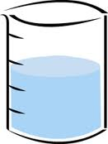
__%
solutes
__%
solutes
__%
solutes
__%
solutes
__%
solutes
__%
solutes

- Compare and contrast Facilitated Diffusion and Active Transport
Facilitated Diffusion | Both | Active Transport

- Name the two main phases of the Cell Cycle. __________________________ & ____________________
- List the 3 phases of Interphase and describe what occurs in each phase.
  - ___________ - _________________________________________________________________
  - ___________ - _________________________________________________________________
  - ___________ - _________________________________________________________________
- Write the 4 stages of mitosis in order.

Use the word bank for the numbers 8-12. You will not use every word.
Word Bank
Centrioles
Chromosomes
Chromatin
Daughter cells
Middle
Nuclei
Sister chromatids

- During the prophase stage of mitosis, the DNA condenses to
form _____________________.
- During the telophase stage of mitosis, two ____________ are formed.
- By the end of cytokinesis, the cell has completely divided into 2
__________________________.
- During the anaphase stage of mitosis, the chromosomes separate into
__________________________.
- During the metaphase stage of mitosis, chromosomes line up in the
_________________________ of the cell .

- Why is it important for the chromosomes to be condensed and align in the middle of the cell during the metaphase stage of mitosis?

- Name 2 reasons why cells must divide.

- What is the result each time a cell completes the cell cycle? _____________________________________
- What is the purpose of checkpoints in the cell cycle?

- _____________________ is the uncontrolled growth and division of cells due to a failure in the regulation of the cell cycle.
- Define carcinogen and provide 3 examples.

- Label the cell below.
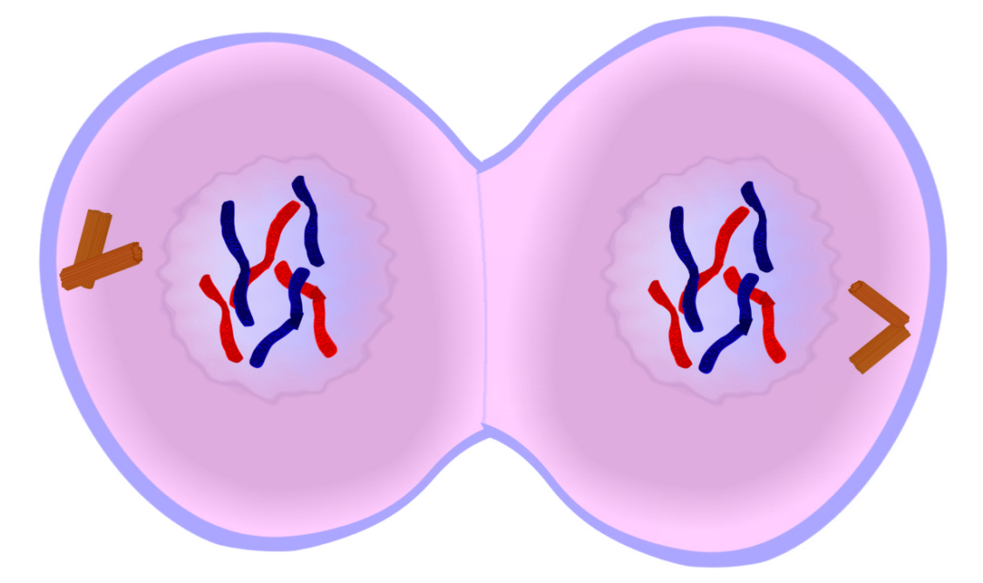
What phase of mitosis is this cell in? _____________________________________________________

- What phase of the cell cycle is the cell below in? 21. Label the phase of mitosis for the diagram below.
